BAHRIA UNIVERSITY (KARACHI CAMPUS)

QUIZ 1

Discrete Structures.

Class: (BSE 1B)
Course Instructor: (FAIZ UL HAQUE ZEYA) Max Marks:2.5
Student’s Name: ____________________ Reg. No: _________

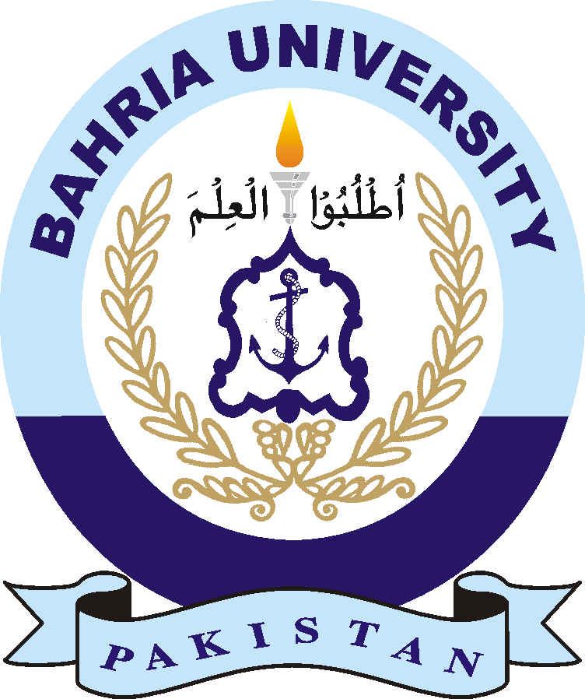

Q1. Convert to Logic.
- All birds are blue.

- The are exactly three Mehran cars

Q2. A ^ B=> C
B V LV K
~L
~K
A^ V
C=?

Q3. Find the truth table of A ^ B <=>C

